MY PROJECT

ABOUT

I have created an interactive prototype app which can be viewed through the link I have shared in the e-mail. There are 10 different screens that can be reached through different buttons in the app.
Each of them has its own purpose. Following are some brief description about it.

SIGN UP PAGE

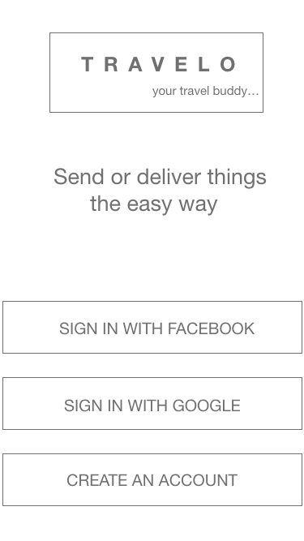

Click any 1

of 3 options

to sign up

HOMEPAGE
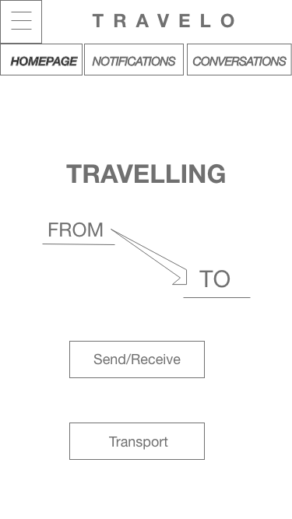

Go to Account too see your info

Go to ‘conversation page’ to message relevant people

Current Page

Tab

Enter starting point of journey

Go to ‘Notification Page’ to see all the updates, cancel or accept requests

Click if you want to carry items for others

Enter end destination

Click to see people willing to carry items for you

ACCOUNT PAGE

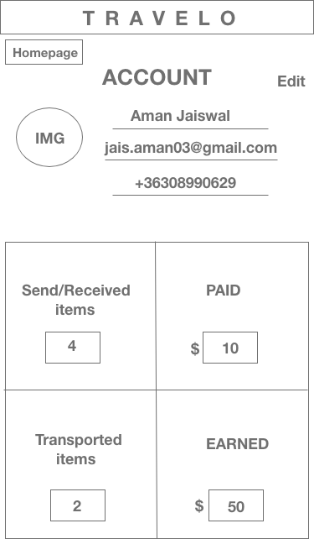

Click to change your name, e-mail, & phone number

SEND/RECEIVE PAGE

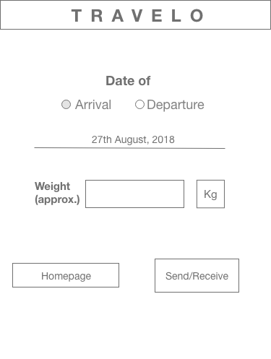

Radio button, choose one.

Enter the desired date

Enter total weight of all items you wish to send/receive

Back to

Homepage

Go to next page

“Matched Results”

MATCHED RESULT PAGE

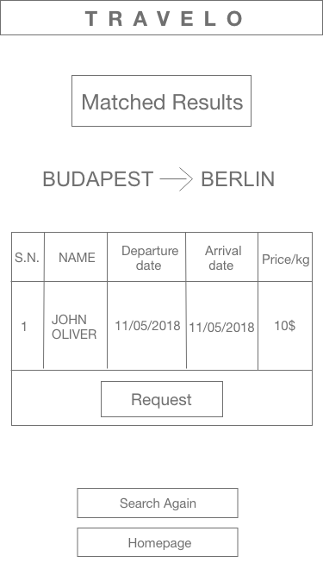

Click to send Notification to traveller. If traveller accepts, you will be notified.

Go back to Send/receive page

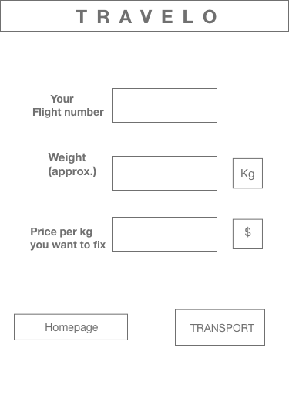
TRANSPORT PAGE

Enter your

Flight number

Enter the total weight you are willing to carry

Enter the price per kg you want to charge your customer

Go LIVE with the above details. Customer can see your offer and travelling details.

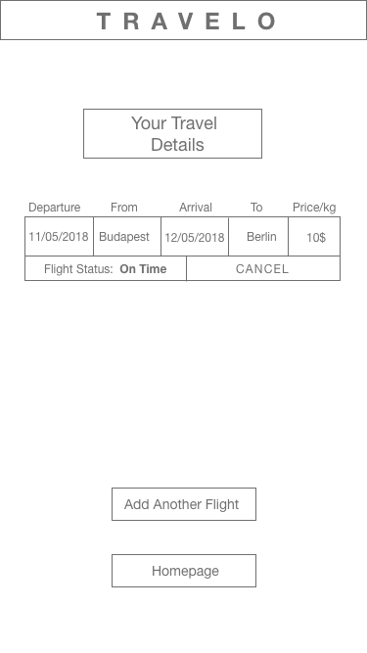
YOUR TRAVEL DETAILS PAGE

As a traveler, cancel this travel plan

Go to Transport page to add new travel details

Back to

Homepage

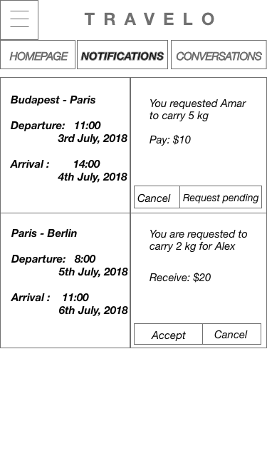
NOTIFICATION PAGE

Current Active Page Tab

Go to Account to view your info

Click to cancel the request made to traveller to carry your item

Show status of your request.

Accept request made by customer to carry their item.

.Cancel the request made by customer.

Denotes you are not interested to carry his/her items

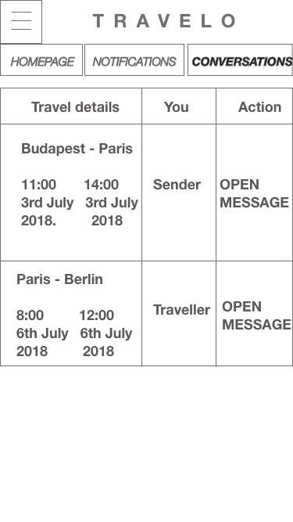
CONVERSATIONS PAGE

Open ‘Messaging page’ where you can chat with all the relevant people involved.

Go to Account to view your info

Current active tab

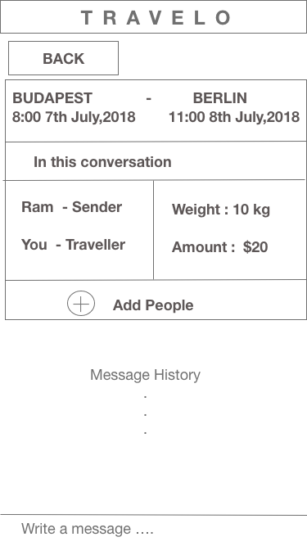
MESSAGING PAGE

Takes you back to the Conversation page

Add relevant people to this conversation for better communication

FAQ

WHO IT WOULD HELP AND WHY DID I CHOOSE THIS PARTICULAR GROUP?

We live in a world where we can see each other, contact each other from anywhere in the world within seconds. However, when we have to send something, it would take days, sometimes weeks for the things to reach to our loved ones. I believe this app has the potential to minimise that gap significantly. From medicines to documents to keys, you name it, it will be far more easier than ever to send it to the desired location and probably in less time than most delivery services guarantee. Furthermore, I think it will make people eager to travel without having to think much about their financial resources as the one travelling gets paid for carrying stuffs with no additional charges. So, its a win-win situation.

HOW DID YOU IDENTIFY THE PROBLEM TO SOLVE AND WHY DID YOU PICK THIS PROBLEM OVER OTHERS?

When I came to Budapest for my further studies, my credit card got swallowed by the ATM machine on the very first day, and the bank wasn’t able to retrieve it. I had no other option than to wait for my card to arrive all the way from Nepal. I had no money for two weeks and had to manage somehow. This is when I wished I knew someone who was travelling to Budapest from Nepal. Eventually I did find someone through Facebook who brought the card safely and seemed rather happy to help me. This is when I realiSed he could have easily charged me a fraction of the huge amount DHL or FedEx was charging and I would have had no problem to pay him too. This is when it hit me that there is a problem and I could solve it. Furthermore, I think it has much broader implications. I chose this problem over others because it is personal to me, something which I have faced myself.

DESCRIBE YOUR APPROACH. HOW DID YOU COME UP WITH IT? IS IT THE BEST POSSIBLE SOLUTION? WHY?

I believe technology is the most obvious solution to this problem as almost everyone has access to it. People travelling via air usually are on their mobiles for easy access to internet. More importantly before boarding and after de-boarding the flight, other devices than mobile are hard to operate. Given the scenario, a mobile application is an obvious choice. I believe a common market place for traveler, sender and receiver of items is the most effective way to ensure the problem is solved. The proposed solution is a fast, probably the fastest, service delivered in fraction of a cost that most courier services charges. For me, it’s the best solution that there could be.

Additionally, I started learning app development from an online course and hopefully I would able to build the fully functional application soon.

